Types Of Holidays
Overview
Lots of tourists spend their summer holidays (AmE vacations) at the seaside. This type of holiday is called beach holiday or seaside holiday. The main activities on that type of holiday are swimming and sunbathing, though other activities such as beach volleyball or snorkelling can be included. Beach holidays are popular in Spain, Greece, Croatia, Egypt etc.
Tourists also go on winter holidays. A typical winter holiday is skiing holiday, though some people prefer snowshoeing, snowboarding etc. Famous skiing destinations are in France, Switzerland, Italy etc.
A weekend break is a type of holiday where tourists stay in a destination for 2 or 3 days, usually Friday, Saturday and Sunday. A weekend break can be a city break, where tourists visit a city or a rural weekend break. Prague, Brussels, Amsterdam or Vienna are examples of city break destinations.
Camping is a type of holiday where tourists stay in tents, caravans or RVs. Glamping means “glamorous camping”. It is a new trend where guests are provided electricity, indoor plumbing and comfortable beds inside the tent, as well as luxurious setting. Glamping is very popular in the UK, France, Italy, Africa etc.
Safari holidays include expeditions where tourists can watch and photograph or hunt animals in their natural habitat, especially in East Africa. Safari holidays are popular in Kenya, Botzwana, South Africa etc.
Adventure holidays are holidays full of activities such as extreme sports or jungle exploration. Some examples of adventure holidays destinations are Nepal, New Zealand, Australia, Iceland...
A farmstay holiday is a holiday on a farm. Guests are allowed to feed the animals, help in the garden, go mushroom picking or fishing. The UK, Germany, France or Spain can provide good farmstay destinations.
Homestay is a type of holiday in which you stay in the home of a local family you meet for the first time, especially combined with language courses abroad. In the UK lots of students who study English can experience a homestay holiday.
Home swap is a type of holiday where people exchange homes for a certain period of time such as a few weeks. It is suitable because you get to know how local people really live, you may meet your host`s family or friends, and if you have similar lifestyle you can have things that are not found in a hotel (lots of toys for kids, a pet dog or cat that you will take care of etc.)
Cruise is a type of holiday where tourists stay on a cruise ship and visit several places, usually for a day or two before they continue the trip.
A luxury train tour takes passengers on a journey through a vast country such as India, Russia, Canada etc. where they stop and visit towns or attractions, while staying on the luxury train.
A coach tour is a tour where tourists travel by coach and visit a few towns. They usually stay in hotels along the way.
Driving/touring holiday is a type of holidays which includes lots of sightseeing and tourists travel by car. Some driving holidays are along scenic routes- roads that offer wonderful view of the countryside.
A fly-drive holiday is a type of holiday where a tourists books a package where a plane ticket and a rented car are included. The car waits for the tourist at the airport. The accommodation is not arranged, but in case the client wants it, it can be booked for him. Clients are recommended the best routes, accommodation and things to do or see. Top fly-drive holiday destinations are Florida and California.
Backpacking is budget travel for young people where they carry a backpack, stay in hostels and visit several places, sometimes across a few countries.
Self-catering holiday is a holiday where you prepare your own food.
Trekking holidays are holidays where people walk in the countryside.
Volunteering holidays are holidays where tourists are provided shelter and food for free, but are expected to participate in volunteering projects without being paid for their work. Volunteering can be connected with childcare, teaching, healthcare or wildlife conservation. Volunteering holidays are available in Africa, Asia, Europe, the USA etc.
A special interest holiday is a holiday where tourists are offered expert tuition in a certain activity they like or want to try. Special interest holidays can be birdwatching (Portugal), photography holidays (Iceland, India), cooking holidays (Italy), wine-tasting holidays (France), painting holidays (Spain), dancing holidays (Cuba), yoga holidays (Greece, Italy, Croatia) etc.
Special requirements holidays or special needs holidays are holidays adapted to groups of people with specific requirements. The examples are disabled travel, vegeterian holidays, over-50s holidays, women-only holidays, singles holidays.
Listening 1
Watch a video about volunteering holidays in Africa and answer the questions:
https://www.youtube.com/watch?v=Waoc3MCXnJc
- Which age group do the volunteers belong to?
- Do they feel safe?
- What sort of tasks are they given?
- What are their impressions?

Reading
Read the text about one unusual type of holidays. Find the meaning of the words in bold.

KAYAK AND WILD CAMP NORWEGIAN FJORDS
Set off on an epic weekend of paddling and fjord-side camping

Kayak and camp along the stunning Nærøyfjord, a UNESCO World Heritage Site for a very good reason.
Access little-visited areas that are only accessible from the water - keep an eye our for seals and eagles.
Enjoy a night under the stars and a barbeque dinner around the campfire - beer and drinks included.

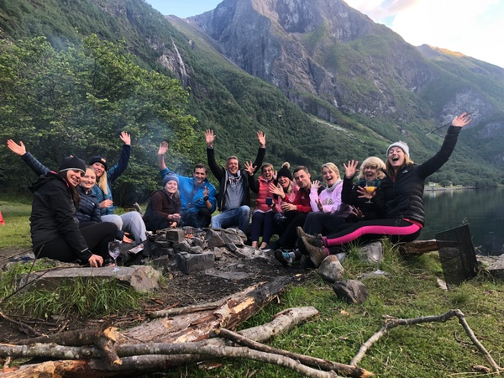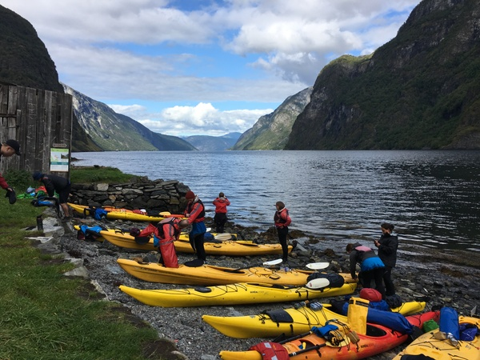

No kayaking experience is needed, just a reasonable level of fitness and the ability to handle 25km of relaxed paddling over two days.

